Upon receipt of a notification that a message has been placed in quarantine, **it is the end user’s responsibility to be sure the message has been reviewed and deemed legitimate** before asking that the message be released by the IT team. It should also be pointed out that over 90% of messages quarantined are NOT legitimate and/or are false-positively labeled – so users need to perform their due diligence prior to making this request.

In an effort to help the user decide whether/not the message is actually legitimate, the following steps should be taken ......

1. Notifications will look similar to that shown below. Users can often determine the legitimacy of a message by reviewing the (**1**) **Sender** and the (**2**) **Subject** of the message. However, if further investigation is needed, the user should then click the (**3**) **Review Message** button to continue the process …

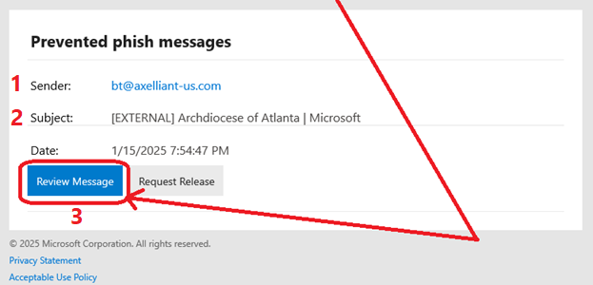

***NOTE: If the message is deemed illegitimate at this point, the notification can simply be deleted from the user’s Inbox, and it will be deleted from the quarantined queue automatically and no more action is required.***

1. Once the **Review Message** button is clicked, the user will be taken to his/her quarantined message screen (similar to what is shown below). This may take a little time to fully load so please allow it to do so. A summary of the actual message will be shown along the right side of the screen.

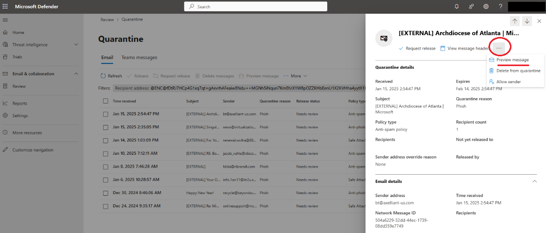

1. To further investigate the message, click on the ellipsis (i.e. the 3 horizontal dots) on the summary window and then choose **Preview message** from the drop down menu …

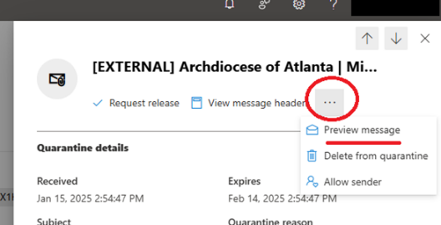

1. A preview screen of the actual quarantined message will then be displayed for the user’s review ….

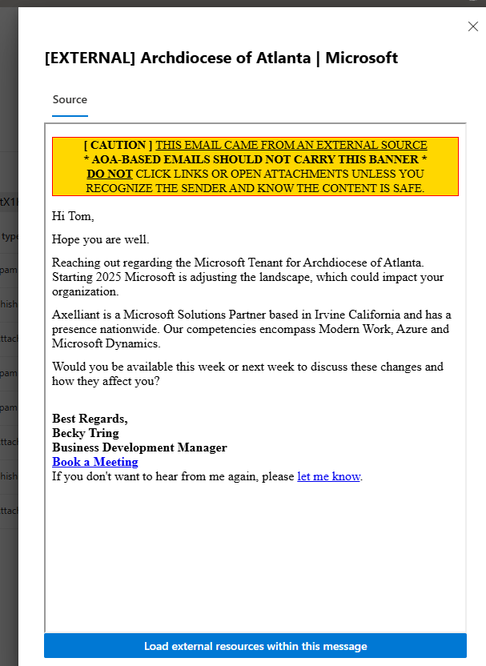

1. If it is determined that the quarantined message is legitimate and necessary, the user can then close this window and choose **Request release** from the previous window (as was shown in step 3 above) …

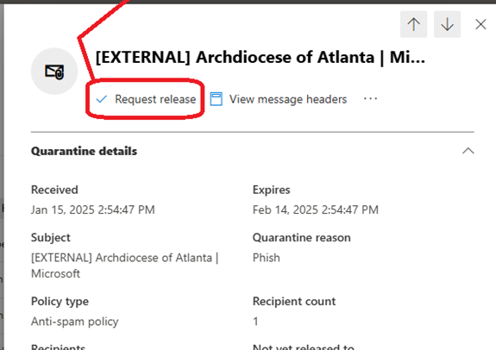

1. At this point, a notification will be sent to the IT team where a final investigation will be carried out to make sure the requested message is not malicious. If determined to be safe, the message will be released to the user’s Inbox.
2. The user can then exit the quarantine queue (as was shown in step 2 above).